Game Design Document

Deadline Force

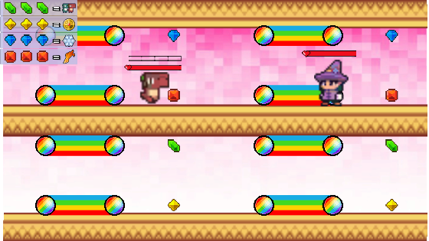

# Team Information

1.1 Team Members

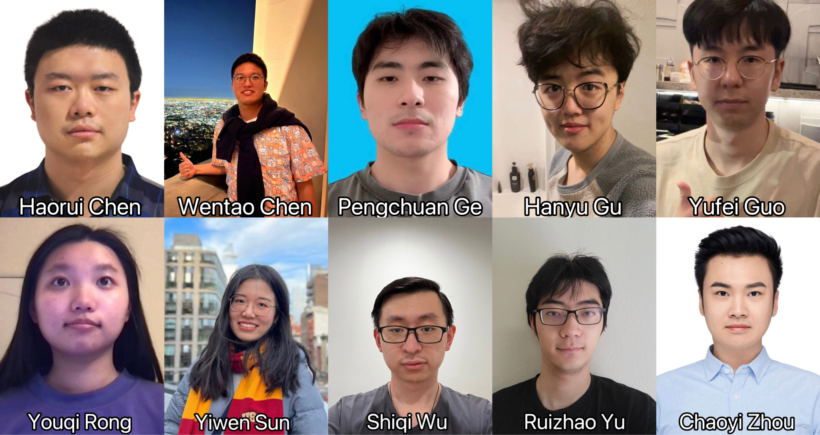

| Name | Email | Roles | Spurpunk gametest |
| --- | --- | --- | --- |
| Ruizhao Yu | ruizhaoy@usc.edu | Captain, System, Physics | https://youtu.be/e8PND8HRvv8 |
| Chaoyi Zhou | chaoyizh@usc.edu | Gameplay, GameTest,Version Control, Music Beats Extraction | https://youtu.be/H6szNBqyH4A |
| Wentao Chen | wchen946@usc.edu | System, UI, Notetaker | https://youtu.be/E0cp56HH2os |
| Pengchuan Ge | pengchua@usc.edu | System, UI | https://youtu.be/X-3CO5hGx-8 |
| Hanyu Gu | [hanyugu@usc.edu](mailto:hanyugu@usc.edu) | Physics | https://www.youtube.com/watch?v=LTE_wy6A9S4 |
| Shiqi Wu | wushiqi@usc.edu | Analytics | https://youtu.be/KaNeeAZDRrM |
| Youqi Rong | youqiron@usc.edu | Music Beats Extraction, Level Design | https://youtu.be/tFmG2QKZi48 |
| Yiwen Sun | ysun4972@usc.edu | System, UI, Tutorial | https://youtu.be/oCgJ8V0kZTs |
| Haorui Chen | haoruich@usc.edu | Physics | https://youtu.be/8WFzI5K_Vv4 |
| Yufei Guo | yufeiguo@usc.edu | Physics | https://youtu.be/ew16dAyZ5Z4 |

1.2 Links

Webgl: [My new microgame - Unity Play](https://play.unity.com/mg/other/my-new-microgame-8167)

Github: <https://github.com/Blazar221/DeadlineForce>

1.3 DevTools and Techs

Git, Discord Server, Visual Studio, Microsoft Paint, GoodNotes, Photoshop, Unity Hub, JetBrain Rider, Tableau

# Game Introduction

2.1 Logline:

Our game is a platformer with rhythm game mechanics and gravity switching

2.2 Goal:

Collect colorful diamond to charge the energy bar and defeat the boss

2.3 General Description

Music Warrior is a platformer game combined with rhythm game mechanics. Players need to collect four different types of diamonds, which is achieved by pressing the correct key when interacting with each game element. Only all four energy bars being full will make an attack. However, different patterns of diamonds can also turn to additional attacks. These game elements occur with the tempos of music.

# Detailed Design

3.1 Game Elements

1. Player - main character, can move between four lanes and collect diamonds and rainbows

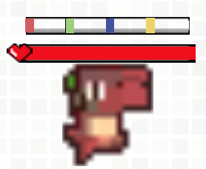

1. Health bar of the player - record the health value of the player
2. Diamonds - four kinds of colorful diamonds, collecting one diamond will increase the corresponding diamond bar

|  |  |  |  |
| --- | --- | --- | --- |

1. Rainbow - collecting rainbow will increase all four diamond bars



1. Diamond bar - record the numbers of different collected diamonds, which have maximum capacity limits, hitting all these limits will cause damage to the boss



1. Boss - unique enemy that has different forms of attack and guards each level, can move between four lanes and attack the player

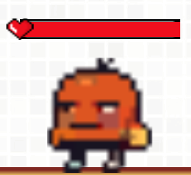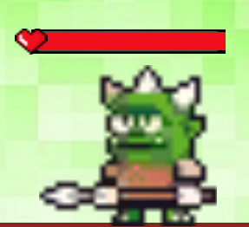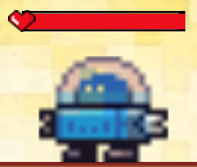

Big Red Orc Rebo

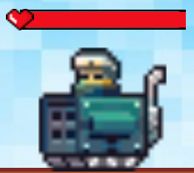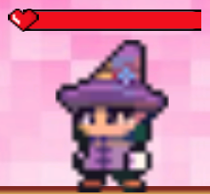

Tank Lil

1. Health bar of the boss - record the health value of the boss
2. Missile - launched by Rebo, track player’s location and attack the player, dissolve after 5.5 seconds



1. Bullet - fired by Tank to attack the player

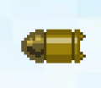

1. Magic spell - cast by Lil to attack the player



1. Laser - fired by Lil to attack the player

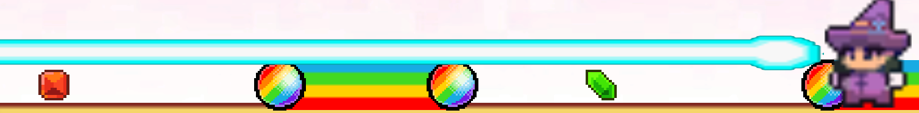

1. Skill panel - collecting certain diamond patterns according to the skill panel will initiates corresponding skills, each skill has a cooldown time

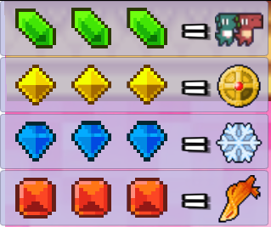

3.2 Game Mechanics

1. Movement mechanics: The character moves automatically from left to right over time, the player can use keyboard to move either up [W / ⬆️] or down [S / ⬇️] at any time:

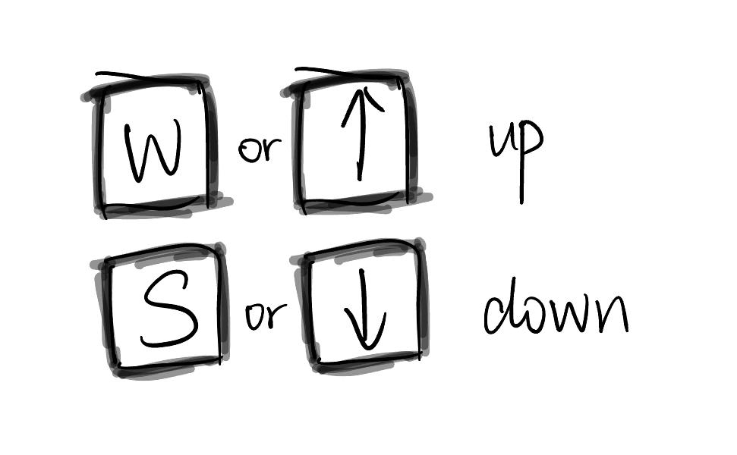

1. Diamond collect mechanics: when diamonds come, at certain checkpoints, player can press [spacebar] to collect diamonds:

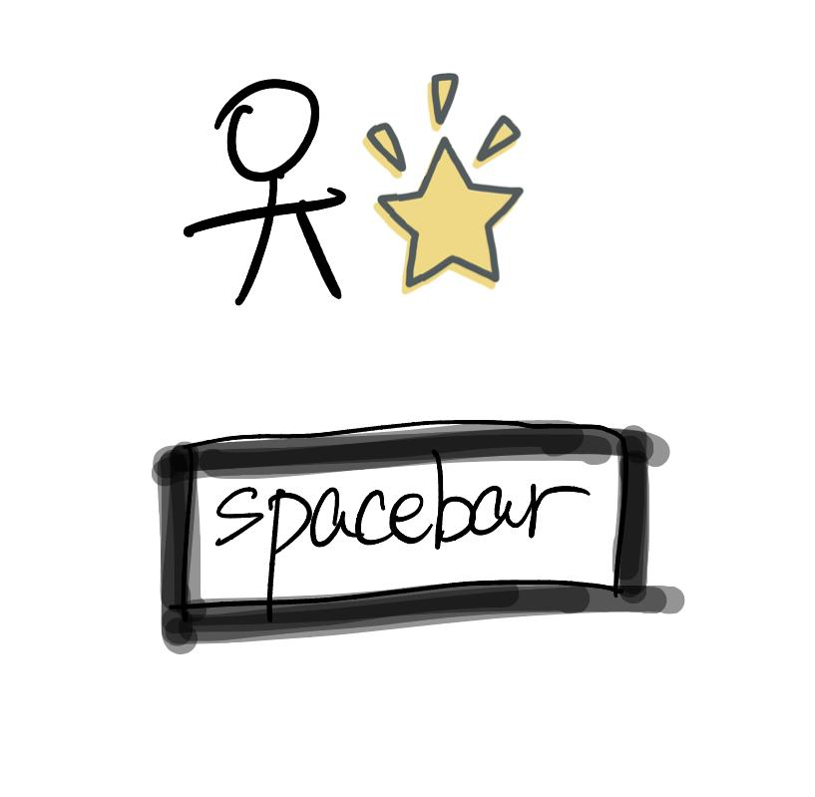

1. Rainbow collect mechanics: when rainbow comes, press [spacebar] and hold continuously to collect rainbow and will increase all four diamond bars:

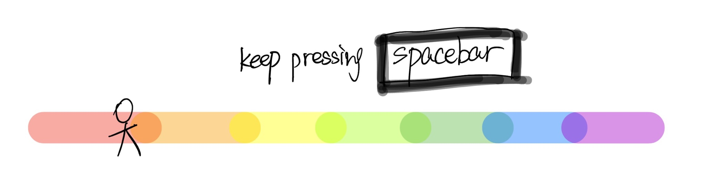

1. Attack mechanics:
   1. Hitting all diamond bars’ maximum capacity limit will automatically attack and cause damage to the boss.
   2. Collecting certain diamond patterns according to the skill panel will activate additional attacks to the boss.

3.3 Game Loop

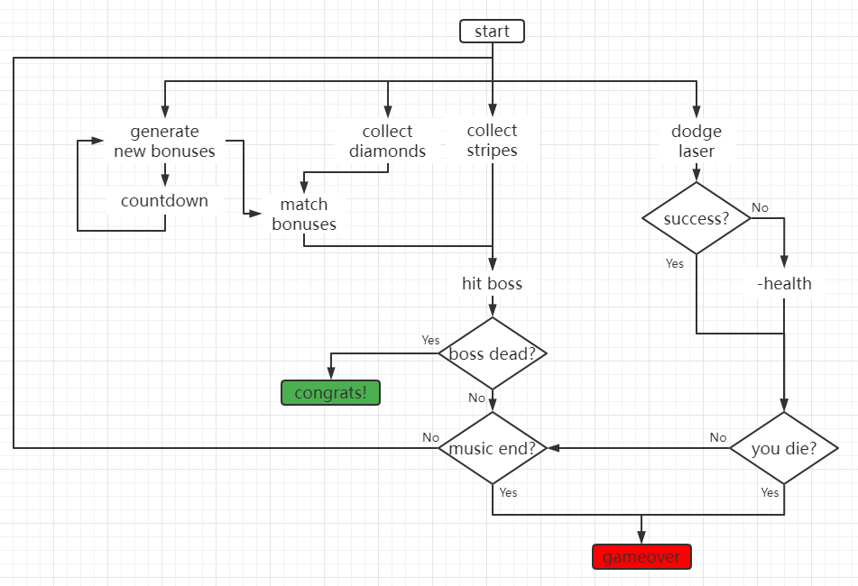

Initial Design Sketch

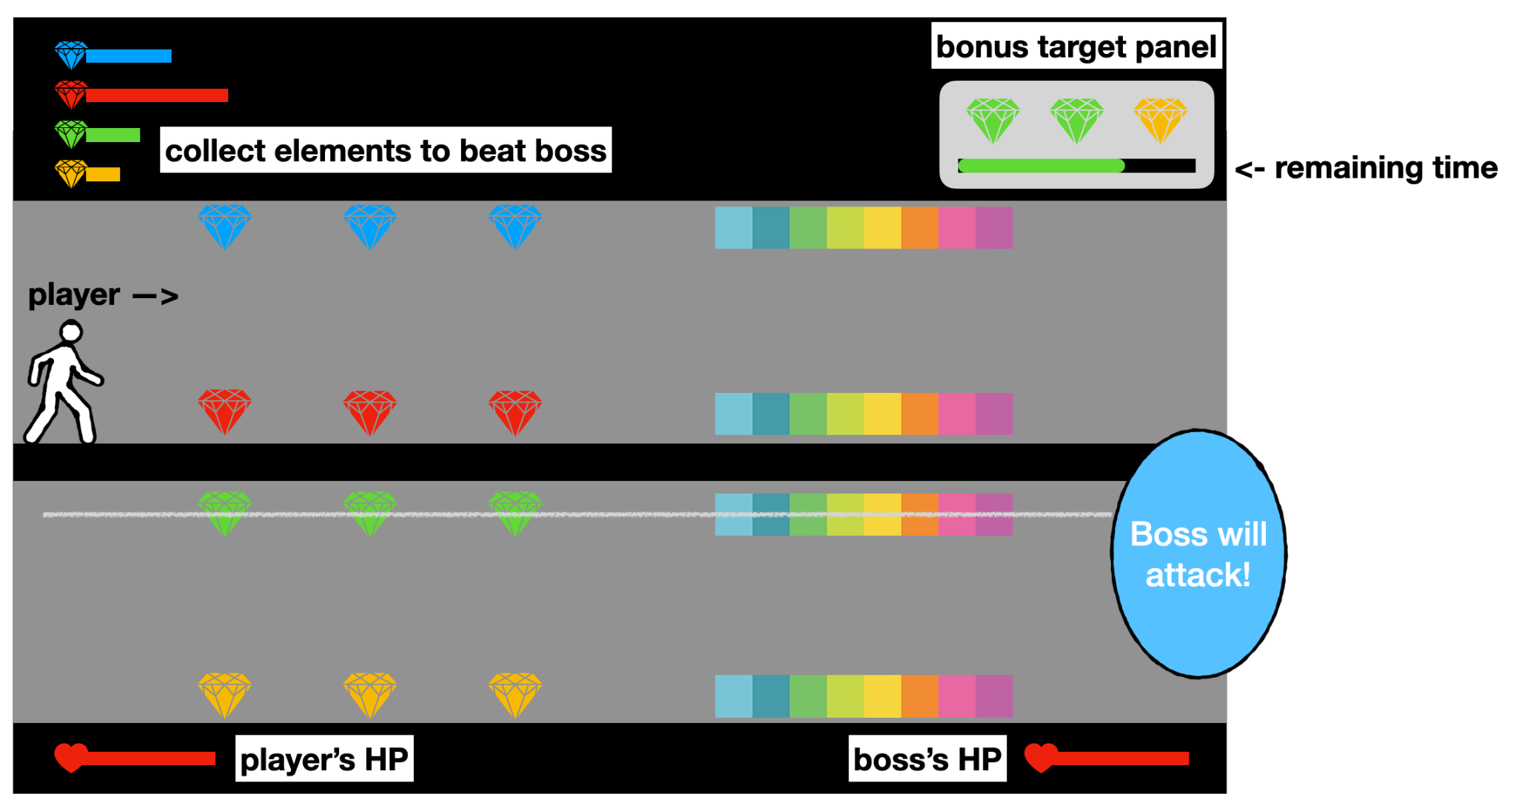

3.4 Greybox Images

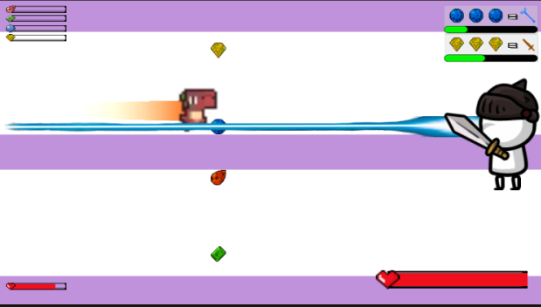

# Analytics

4.1 Statistics graph:

| Mockup | Actual result |
| --- | --- |
| We chose this graph because it shows how much time players spent in order to complete the level. This would tell us whether or not the setup of each level is reasonable |  |
| We chose this graph because it shows how far players are from killing the boss when the game is completed. This would tell us whether or not we made boss too tough to be killed |  |
| We chose this graph because it shows how much health remains when the game is completed. This would tell us whether or not we made the boss attack too hard to be dodged |  |
| We chose this graph because it demonstrates which path players preferred in each section of the level. This would tell us if all paths are tempting enough for some players to choose. The number on the bar represents the path players were on for over 30% of time for the section |  |
| We chose this graph because it shows how long it takes each time for a player to collect enough diamonds to construct an attack. If the time in general is longer than expected, that would indicate this mechanic is too hard for new players, and we would need to reconsider it. |  |
| We chose this graph because it shows how many players have managed to complete each quest in the game. If there were quests that almost nobody has completed, then we would reconsider the design of those quests. In the graph, 0 (blue bar) means incomplete, and 1 (orange bar) means complete |  |

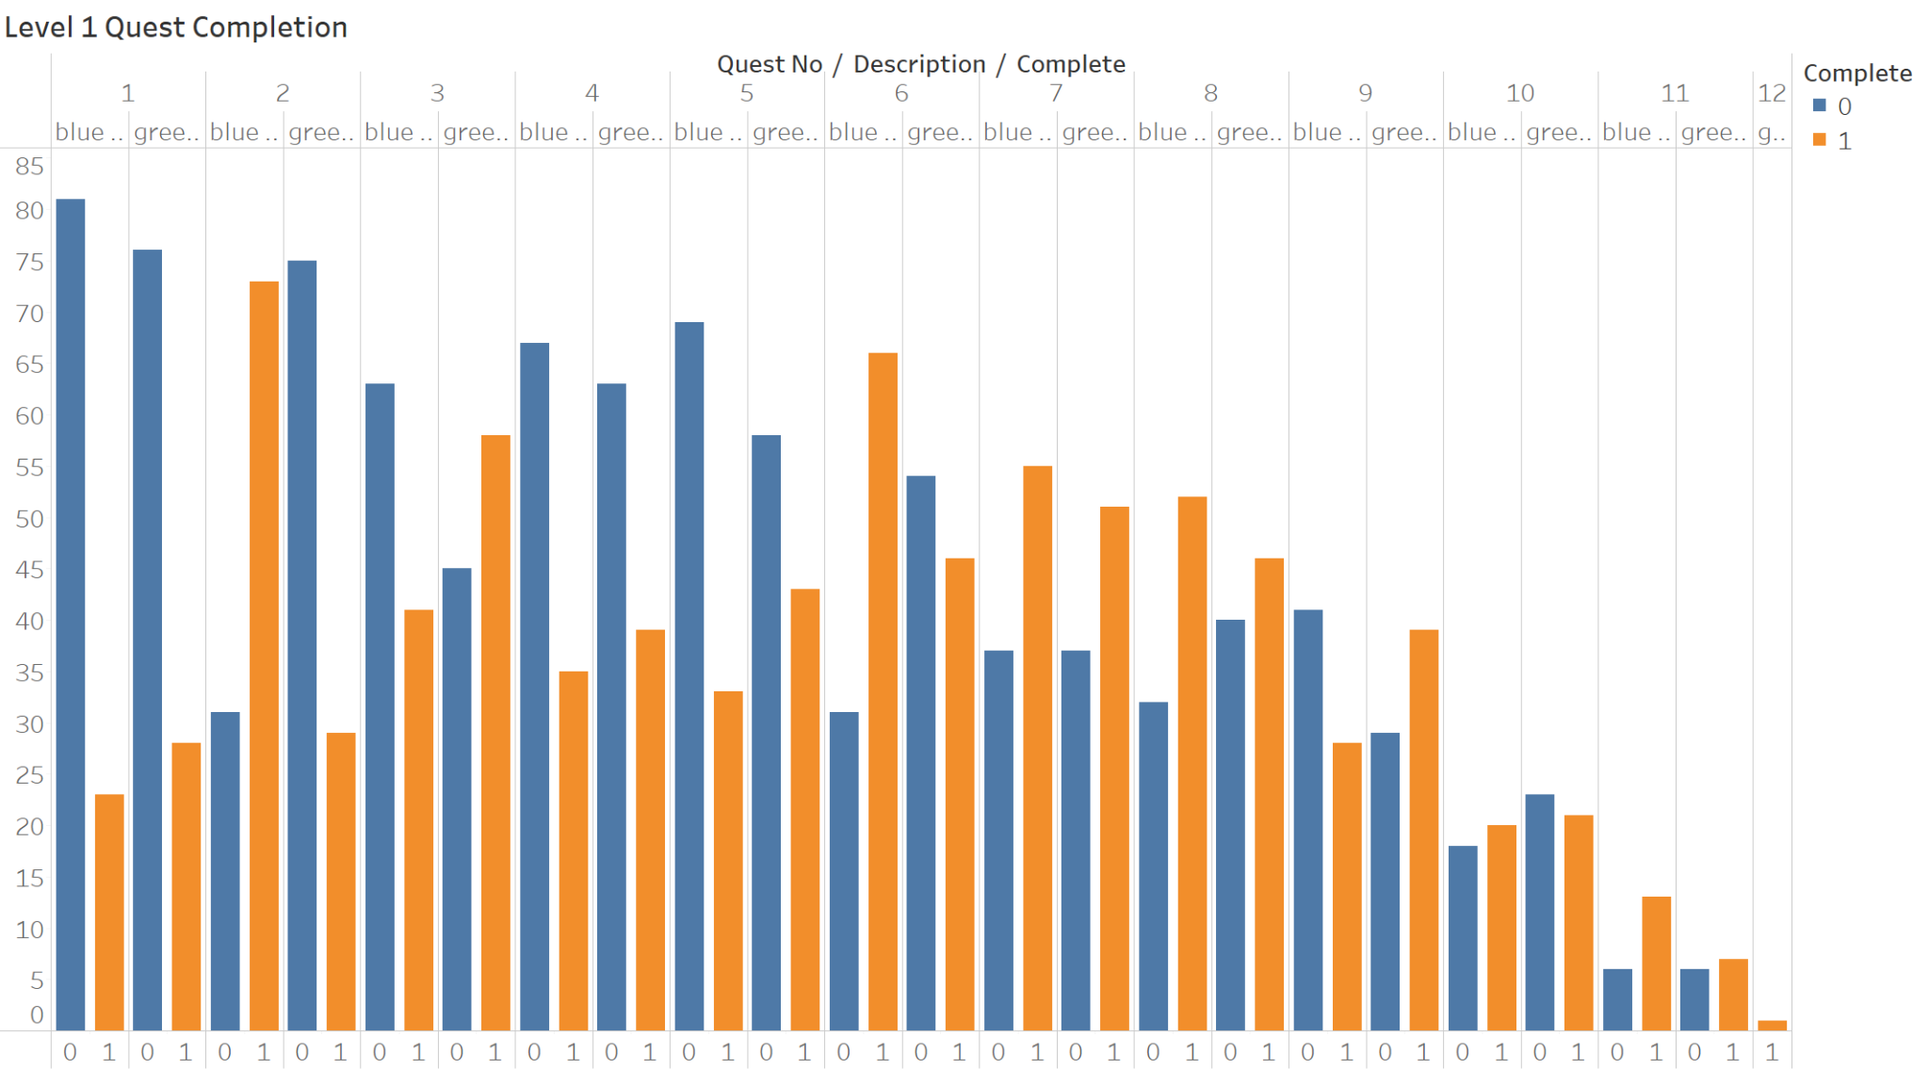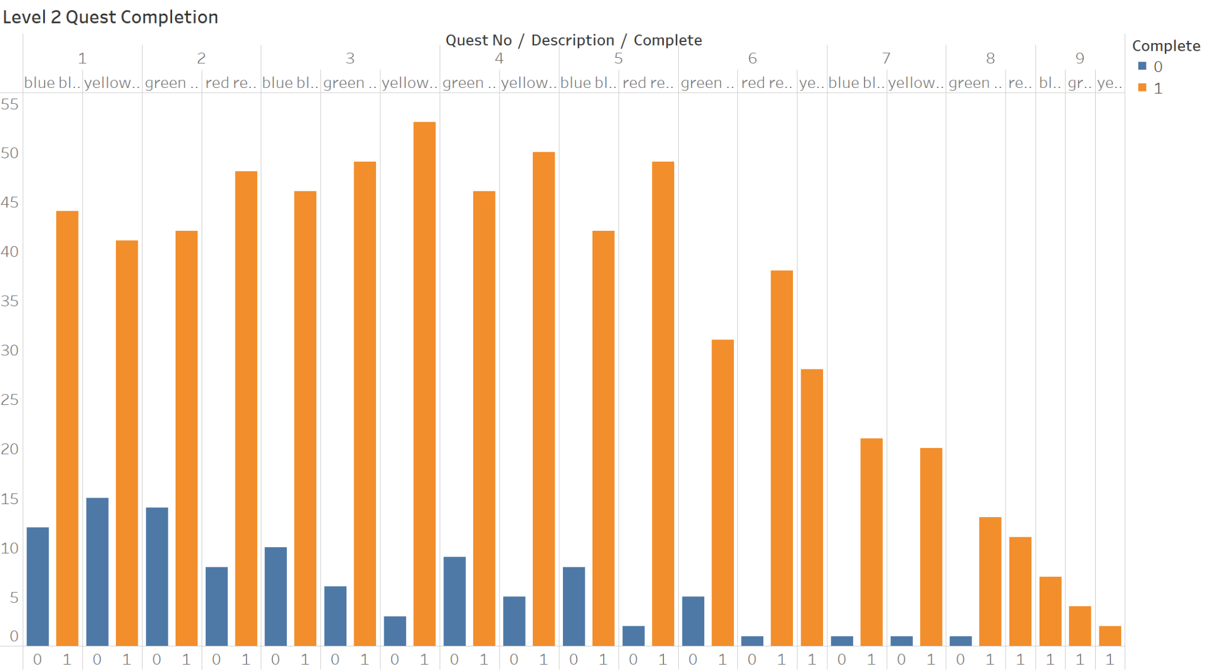

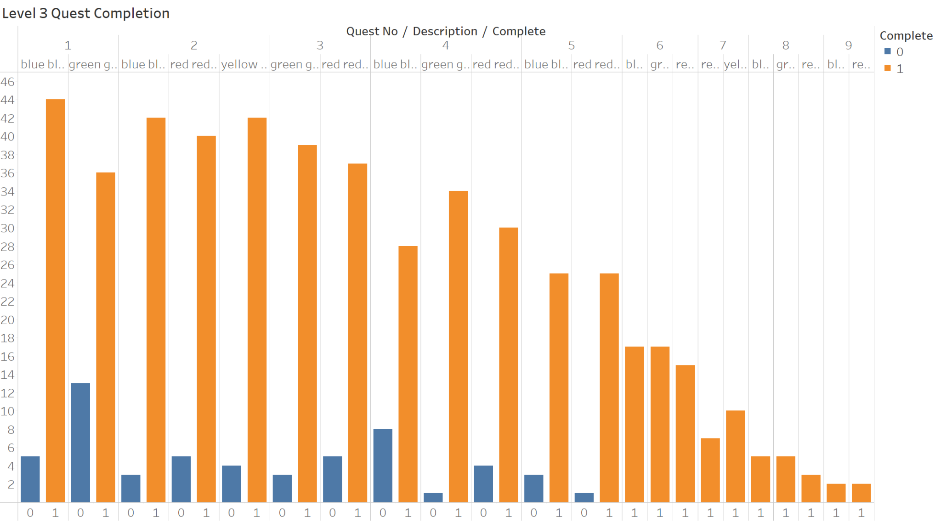

4.2 Analytics and Questionnaire Feedback Insights

1. Tutorial didn't present the expected outcome of certain plays, such as collecting four types of diamonds and completing patterns, and what it's like to finish off the boss
2. Some players are complaining about game controls being too complicated, and they found it difficult to press the right buttons at the right time
3. Level 2 and Level 3 are very hard to pass, and passing rate is way lower than expected. Most players run out of time without dying in level 2 while they end up dying in level 3, however, the graph shows they are capable of completing almost all patterns in level 2 and level 3, which leads to the hypothesis that they are either unaware of the regular attack or too busy to even worry about that
4. Players can easily collect as many diamonds as possible if they keep smashing collect key all the time as there is no penalty for pressing the key when nothing is collected
5. There are too many things shown at different places on the screen, which makes UI distracting
6. More graphics and animations need to present when performing attacks as it is not clear whether the attacks are made without animations

4.3 Things to improve

1. **Make the objective clear.** A lot of players said it took them a while to figure out their goals and how to pass the level. We will make a more detailed tutorial to fix it.
2. **Choose common key binding.** Some of the feedback said our key binding is not well used by other games so they have to get used to it. We will change them to a more reasonable key binding.
3. **Make the player's attacks more obvious.** Some players said they were not sure whether they had made an attack or not. We will add attack and damaged animations on characters to notify players.
4. **Simplify the UI and make important objects stand out.** A lot of feedback said there were too many things that require players’ concentration. We will rearrange the UI so players can see the priority order of different mechanics.
5. **Adjust game speed.** A few feedback said the speed of gems is too fast. We will choose some slower BGMs and lower the speed of the gem.
6. **Add more elements to different levels.** Each of the levels we have now is similar. We consider assigning different bosses with different attacking patterns to each level.
7. **Add rainbow collection effect.** Some players said they did not get any visual feedback when collecting rainbows. We consider adding the effect that the rainbow will disappear gradually while players are collecting it.

4.4 Data Collection Methodology

1. Setup Google Form with sessionID as identifier along with metrics to be tracked
2. In Unity, create a C# script that contains Send() method and call this method whenever a level is completed or the character is dead.
3. Create an empty object called AnalyticManager and attach the script created above to this object. Also enter the Google Form URL in the serialize field of the spector section
4. Once the setup is completed, the google form will start receiving data every time a player has completed one game
5. Write a python script to transform the collected data into an ideal format for visualization
6. Data Collection Spreadsheet

Level1:<https://docs.google.com/spreadsheets/d/1zcwTqpvHrzx57GLD2o5cr9YduT4JtG75Yfh2x4c0RpU/edit?resourcekey#gid=247952288>

Level2:<https://docs.google.com/spreadsheets/d/18sxD3w1UizwcvA_ZeVBLlg3CJUvN9EMb-EzzNZkqd1g/edit?resourcekey#gid=1375563309>

Level3:<https://docs.google.com/spreadsheets/d/1JhfLUd55ReOL4BT6ioghlYwkxwcOD7SEwz4hnfD0IEU/edit?resourcekey=undefined#gid=787628772>

# Review Notes

9.16 Notes:

Issue1:The player quickly drops out of screen quickly after playing the game

Issue2: The obstacle moves too fast

Issue3: Once the player collides with any obstacle, they drop out of screen

Issue4: The rhythm game elements is too little

Potential Solution: Change the collision setting. Add more elements derived from rhythm games. Tune the player and obstacle moving speed.

9.23 Notes:

Issue1: Restart button breaks down

Issue2: Gravity switch is too small to notice

Issue3: After game end, the summary is too simple

Issue4: Use blocks of text as tutorial

Potential Solution: Debug the restart button issue. Change game element sprite. Make an independent tutorial level. Add more analytics data.

9.30 Notes:

Issue1: Choice of switching gravity system

Issue2: Need different ways of forwarding

Issue3: Require new mechanics when entering a new level

10.7 Notes:

Issue1: Level 2 is much harder than level 1.

Issue2: Score is meaningless.

10.28 Notes:

Issue1: The progress of collecting diamonds ought to be at an eye-catching position.

Issue2: The health bars of boss and player need to be put above the heads.

11.4 Notes:

Issue1: Make boss dead in tutorial level

Issue2: Lack of feedback when doing damage to the boss

Issue3: The collection is too much to evaluate what combo is doing.

Week 11 Feedback:

Issue 1: Cooldown time is too long

Issue 2: Warning for boss attack appears too late

Issue 3: Punishment is too heavy when pressing space mistakenly/attacked by boss

Issue 4: Make missile disappear after being spawned for a while in level3

Week 12 Feedback:

Issue 1: In the tutorial, don’t use the same key to progress the hint and interact with the game object.

Issue 2: Not intuitive which line will boss be attacking

Issue 3: The 4 bars behind the hero is not of help

Issue 4: No way to heal

Issue 5: Combos are of very little effect, make it worthy to gather those combos

Issue 6: Better to fix the correspondence between gadgets and gem combination and let player learn one for each level

Issue 7: No changes among bosses, which kinda make the game boring

Week 13 Feedback:

Issue 1: Fix grammar errors in tutorial

Issue 2: Better to disable keyboard input when it’s not time for player to press key in tutorial

# References

6.1 References Table

| Name | Link | Usage |
| --- | --- | --- |
| Python Library librosa | <https://librosa.org/doc/latest/index.html> | Analyze .mp3/.wav music files |
| Python Library Mido | <https://mido.readthedocs.io/en/latest/> | Read .midi music files |
| Line Renderer Script | <https://answers.unity.com/questions/1343711/trail-effect-for-non-moving-object.html> | Trai Line after character |
| Dino Characters | <https://arks.itch.io/dino-characters> | Assets for player characters |
| Sprite Pack 5 | <https://grafxkid.itch.io/sprite-pack-5> | Assets for boss characters |
| PISKEL | https://www.piskelapp.com | Create own sprites online |
| Flower Dance Inst Ver. |  | Song for Level 1 |
| Lonely Warrior Inst Ver. |  | Song for Level 2 |
| Patreon Goal Reward |  | Song for Level 3 |
| Power Remix Ver. |  | Song for Level 4 |
| Unity Piano Ver. |  | Song for Level 5 |

6.2 Tutorials

Week1-4

<https://www.youtube.com/watch?v=OR0e-1UBEOU&list=PLKz-FFGhburUUeB6kXkwKwzte_pBfMlYx&index=2>

<https://www.youtube.com/watch?v=FO7y5ar-Xl8&list=PLKz-FFGhburUUeB6kXkwKwzte_pBfMlYx&index=5>

<https://www.youtube.com/watch?v=ailbszpt_AI&list=PLKz-FFGhburUUeB6kXkwKwzte_pBfMlYx&index=6>

<https://www.youtube.com/watch?v=qpXxcvS-g3g&list=PLKz-FFGhburUUeB6kXkwKwzte_pBfMlYx&index=1>

<https://www.youtube.com/watch?v=A5YSbgqr3sc&list=PLKz-FFGhburUUeB6kXkwKwzte_pBfMlYx&index=3>

<https://www.youtube.com/watch?v=X7-1Mr9w6Sk&list=PLKz-FFGhburUUeB6kXkwKwzte_pBfMlYx&index=4>

[https://youtu.be/W3-EncfpBZM](https://www.youtube.com/watch?v=W3-EncfpBZM&t=0s)

[https://youtu.be/nDAZIKNx0wg](https://www.youtube.com/watch?v=nDAZIKNx0wg&t=0s)

[https://youtu.be/vmbZsbdqza0](https://www.youtube.com/watch?v=vmbZsbdqza0&t=0s)

[https://youtu.be/9OV_M5PpjPY](https://www.youtube.com/watch?v=9OV_M5PpjPY&t=0s)

[https://youtu.be/jdAoLlCn2e8](https://www.youtube.com/watch?v=jdAoLlCn2e8&t=0s)

[https://youtu.be/jdAoLlCn2e8](https://www.youtube.com/watch?v=jdAoLlCn2e8&t=0s)

<https://www.youtube.com/watch?v=TcranVQUQ5U&t=465s>

<https://youtu.be/Gf8LOFNnils>

<https://youtu.be/_UBpkdKlJzE>

<https://youtu.be/yshKlol5pHM>

<https://youtu.be/M4O8UOEl5Tg>

<https://youtu.be/ZgweU071Y8U>

<https://youtu.be/XOtG8jruX_k>

<https://youtu.be/vbUat8vMePE>

Week5

Week6

Week7

[Coding to the Beat - Under the Hood of a Rhythm Game in Unity (gamedeveloper.com)](https://www.gamedeveloper.com/audio/coding-to-the-beat---under-the-hood-of-a-rhythm-game-in-unity)

<https://learn.unity.com/tutorial/introduction-to-object-pooling#5ff8d015edbc2a002063971d>

Week8

<https://www.youtube.com/watch?v=2WnAOV7nHW0>

Week9

<https://www.youtube.com/watch?v=AD4JIXQDw0s&t=395s>

<https://youtu.be/AoD_F1fSFFg>

https://www.youtube.com/watch?v=2_Hn5ZsUIXM

Week10

Week11

[2D Character Hitpoints in Unity / 2022](https://www.youtube.com/watch?v=v1UGTTeQzbo)

[Unity 2D Lights and Shadow 2022! || Unity 2D Tutorial](https://www.youtube.com/watch?v=Jf1w_wUibnA)

Week12

Week13

# Weekly Homework

## Homework - One Paragraph Game Description and Game Sketches

2.1 Game Basic Info

Name:

Music Warrior

Genre:

Platformer + Rhythm

Overview:

Player controls the character to do different actions corresponding to the beats of music to avoid obstacles and reach the destination.

Mechanics:

Jump and slide

Math:

Convert music beats to time data and spawn obstacle

Convert users’ input data to action, including which button and how long it is pressed

2.2 Idea Drawing

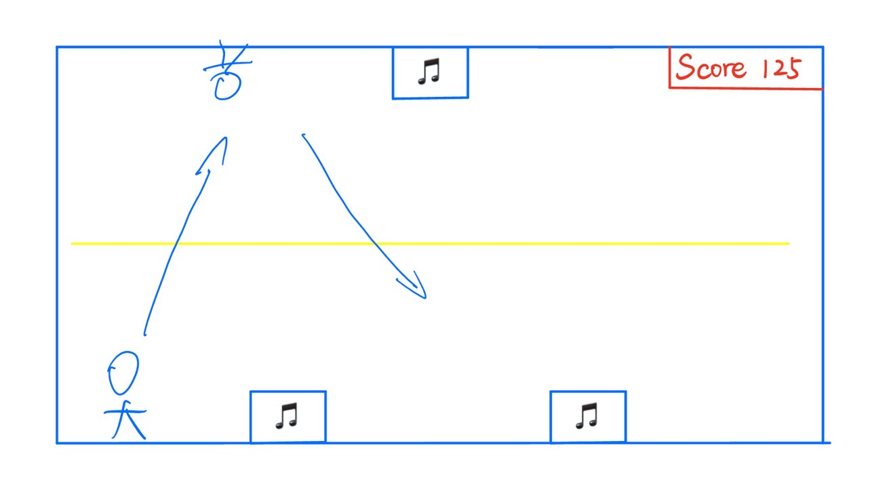

## Homework - Prototypes per 3 Team Member

Vertically Scrolling Shooting Game: <https://play.unity.com/mg/other/build-uwz>

2D Runner: <https://play.unity.com/mg/other/webgl-builds-244005>

Rhythm Jump: [https://play.unity.com/mg/other/webgl-1r8Webgl:](https://play.unity.com/mg/other/webgl-1r8)

Team1(Vertically Shooting game): Ruizhao Yu, Haorui Chen, Hanyu Gu

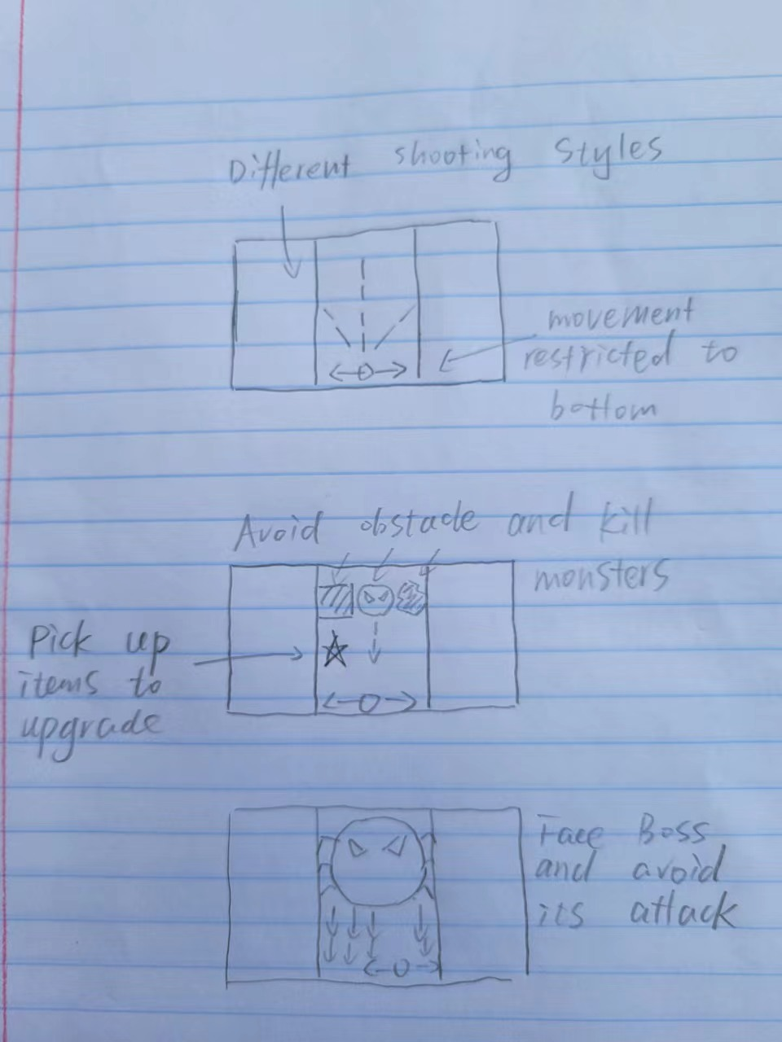

Game Overview: TBD is a vertically shooting game with endless running game element. Player controls a tank to avoid obstacles and shoot enemies to upgrade weapons. Different weapons have different shooting routes. There are also different skills to strengthen the player’s tank, like speeding up, shield or aoe. Finally the player needs to face the ultimate boss and defeat it to win the game.

Tutorials:

<https://www.youtube.com/watch?v=OR0e-1UBEOU&list=PLKz-FFGhburUUeB6kXkwKwzte_pBfMlYx&index=2>

<https://www.youtube.com/watch?v=FO7y5ar-Xl8&list=PLKz-FFGhburUUeB6kXkwKwzte_pBfMlYx&index=5>

<https://www.youtube.com/watch?v=ailbszpt_AI&list=PLKz-FFGhburUUeB6kXkwKwzte_pBfMlYx&index=6>

<https://www.youtube.com/watch?v=qpXxcvS-g3g&list=PLKz-FFGhburUUeB6kXkwKwzte_pBfMlYx&index=1>

<https://www.youtube.com/watch?v=A5YSbgqr3sc&list=PLKz-FFGhburUUeB6kXkwKwzte_pBfMlYx&index=3>

<https://www.youtube.com/watch?v=X7-1Mr9w6Sk&list=PLKz-FFGhburUUeB6kXkwKwzte_pBfMlYx&index=4>

[https://youtu.be/W3-EncfpBZM](https://www.youtube.com/watch?v=W3-EncfpBZM&t=0s)

[https://youtu.be/nDAZIKNx0wg](https://www.youtube.com/watch?v=nDAZIKNx0wg&t=0s)

[https://youtu.be/vmbZsbdqza0](https://www.youtube.com/watch?v=vmbZsbdqza0&t=0s)

[https://youtu.be/9OV_M5PpjPY](https://www.youtube.com/watch?v=9OV_M5PpjPY&t=0s)

[https://youtu.be/jdAoLlCn2e8](https://www.youtube.com/watch?v=jdAoLlCn2e8&t=0s)

[https://youtu.be/jdAoLlCn2e8](https://www.youtube.com/watch?v=jdAoLlCn2e8&t=0s)

Team 2 (Platform Running Game): Pengchuan Ge, Shiqi Wu, Yufei Guo, ~~Yufei Guo~~Chaoyi Zhou

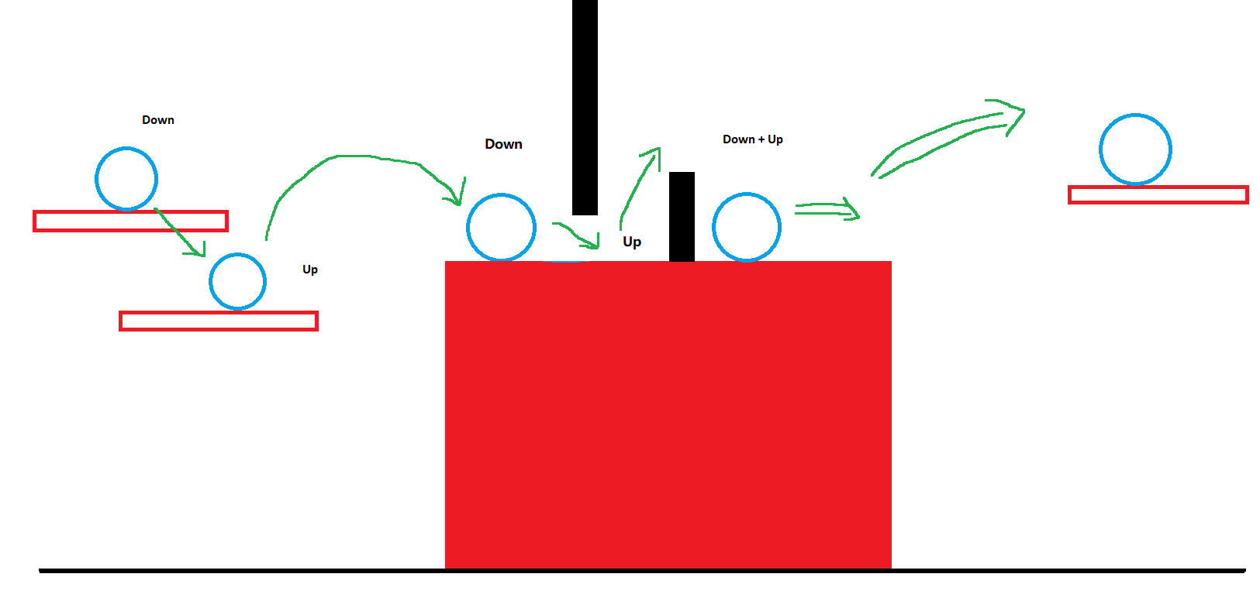

Game Overview: A guy starts running from the left checkpoint and tries to make it to the finishing line without falling down or getting blocked by obstacles. The guy can either get down from a floating board, drop down faster while in the air, or jump from board or ground to another. Some obstacles require the character to crouch, and some with larger gaps in between require the character to perform an accelerated jump in order to land.

Tutorials that followed:

<https://www.youtube.com/watch?v=TcranVQUQ5U&t=465s>

<https://youtu.be/Gf8LOFNnils>

<https://youtu.be/_UBpkdKlJzE>

<https://youtu.be/yshKlol5pHM>

<https://youtu.be/M4O8UOEl5Tg>

<https://youtu.be/ZgweU071Y8U>

<https://youtu.be/XOtG8jruX_k>

Team 3 (rhythm jump): Youqi Rong, Yiwen Sun, Wentao Chen

Game Overview: A character jumps between two walls which have spikes. When the game begins, the player starts sliding from the wall. When clicking on the screen, the character will jump up the other wall. If the character hits the spike, it will lose one point of life. Moreover, there is a booster system on the top of the scene. This system is a rhythm game, if the character keeps jumping with the given rhythm of background music for greater than or equal to five times, the character will become invincible for the next five seconds. The game will be over until the character loses all points of life.

Tutorial links are shown below:

<https://youtu.be/vbUat8vMePE>

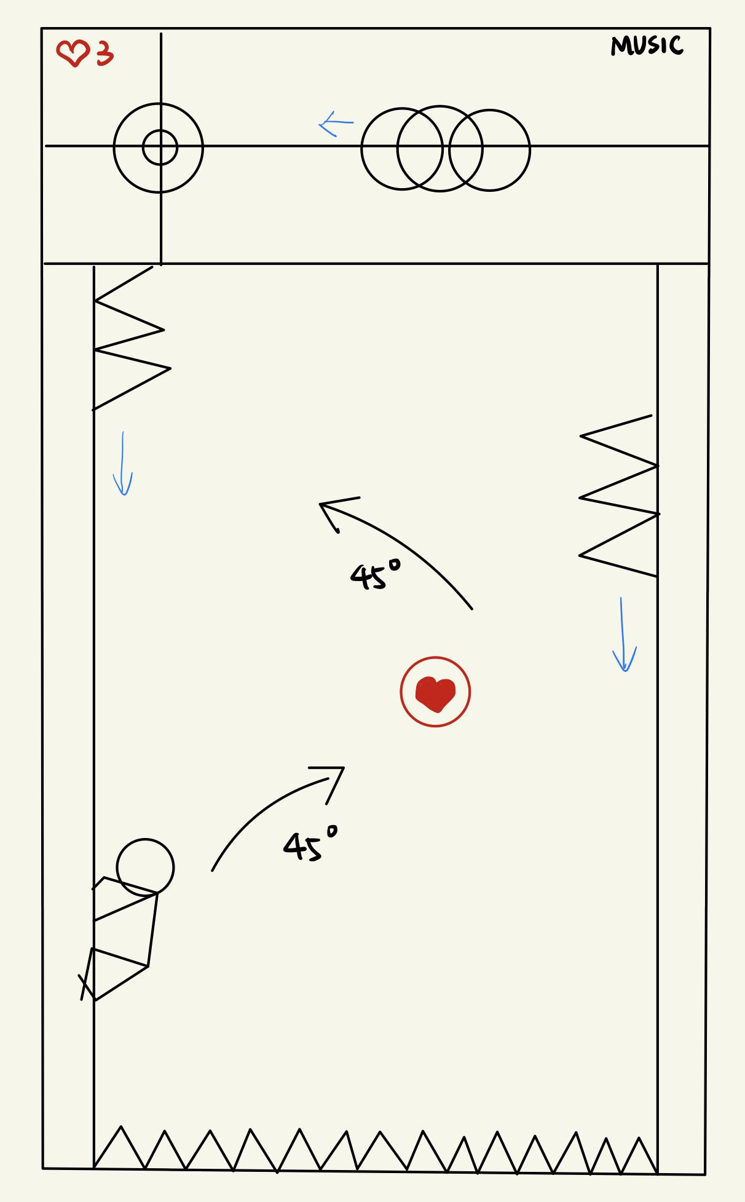

## Homework - Games Played Per Team Member

| Name | Three Mobile Game | Game Genre |
| --- | --- | --- |
| Ruizhao Yu | 1. Sonic Dash 2. Hill Climb2 3. Kingdom Rush | 1. Endless Running 2. 2D Car Racing 3. Tower Defense |
| Chaoyi Zhou | 1. Honor Of Kings 2. The Legend of Zelda: Breath of the Wild 3. DouDiZhu online | 1. Multiplayer online battle arena (MOBA) 2. Open world, Role playing game 3. Card game |
| Wentao Chen | 1. Classic Miner 2. They Are Coming 3. BitLife | 1. Gold Rush 2. Endless Elimination 3. Word Game |
| Pengchuan Ge | 1. Subway surfers 2. Deemo 3. Dead cells | 1.Endless Runner  2.rhythm  3.rouguelike |
| Hanyu Gu | 1. Generate Melons 2. Raiden 3. Elimination fun | 1. Elimination game (user add new item in right place to eliminate) 2. Elimination game (new items come endlessly for users to eliminate) 3. Elimination game (user eliminate items by matching same color) |
| Shiqi Wu | 1. Ninja Must Die 3 2. Candy Crush 3. Piano Tiles | 1. Endless Runner 2. Puzzle 3. Rhythm |
| Youqi Rong | 1. Doodle Jump 2. Xiaoxiaole 3. Plants vs Zombies | 1. Endless runner 2. Same color match game 3. Tower defense |
| Yiwen Sun | 1. Subway Surfers 2. Crazy Arcade 3. SuperStar SMTown | 1. Endless runner 2. Multiplayer maze strategy game 3. Rhythm |
| Haorui Chen | 1. Raiden III 2. Temple Run 3. World of Warships | 1. Scrolling shooter 2. Endless Runner 3. MMO slow-pace shooting |
| Yufei Guo | 1. Drop the Number 2. Brawl Star 3. Survivor.io | 1. Sliding Block Puzzle 2. Third-person shooter 3. Arcade Action Survival |

## Homework - Ten Improvement Plans

| **Problems** | **Improvement** | **Progress** |
| --- | --- | --- |
| **The objective is not clear** | **-> make our tutorial more detailed**  **-> separate tutorial to several parts, each part focusing on a perspective of the gameplay**  **-> The player need to defeat boss to pass the tutorial** | **Complete** |
| **Control key is not usual** | **->Change action key from “J”, “K” to spacebar / Add arrow key control** | **Complete** |
| **How player attack works is not clear** | **->Add player attack animation; Add boss take damage animation, to give user feedback** | **Complete** |
| **Cannot focus on many things simultaneously; Too many things on the screen** | **->Energy bar and health bar follow the character, so they only need to stare at their character**  **->Make skill pattern fixed, so they don't need to check skill from time to time** | **Complete** |
| **Gamespeed is too fast** | **->Change background music to slower one**  **-> Make the game speed slower** | **Complete** |
| **Keep pressing K can pass all the levels** | **->Player will lose health when there are no diamonds to eat** | **Complete** |
| **Attacking pattern is simple** | **->New Skill added: shield, clone, freeze** | **Complete** |
| **Each level is similar** | **->Different boss with unique attacking style each level** | **Complete** |
| **Don’t know why game ends** | **->Add more animation to the boss**  **->Health bar follows boss** | **Complete** |
| **How rainbow works is not clear** | **-> Rainbow consuming effect** | **Incomplete** |